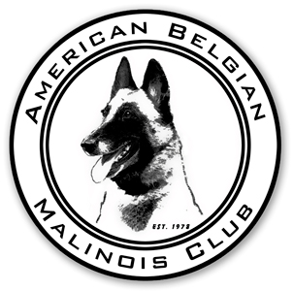
American Belgian Malinois Club, an AKC Member Club

Membership Renewal Form & Notice for 2015
Return to: Jane Rothert, 2705 Clifton Drive, Urbana, IL 61802-7621

Please return this form with your dues. $5 late fees apply on renewals that are postmarked after December 31, 2014 and before March 1, 2015. AFTER March 1, 2015 unpaid memberships are considered lapsed, and require a new application and sponsor. This policy will be STRICTLY enforced.

If you would like verification that your renewal was received, please include a self-addressed stamped envelope/postcard.

All members, including each family member, must verify that they are in good standing with the AKC by signing in the space below. (Note all members included in a family membership must have gone through the membership application process).

Donations to the Rescue Fund are made as a separate check payable to the ABMC Charitable Trust. Contributions to the trust are tax deductible and a receipt will be sent to you for your records.

Donations to the health and national funds will be gratefully accepted. The IRS has asked us to state that membership dues and donations to the health & national funds are not tax deductible.

Any questions? Please contact Angela McCalla, Second Vice-President, at 804.479.5857 or malinois@delriokennels.com

ABMC 2015 Membership Renewal
Names:
Address:
Email:
Website:
Home phone: |  | List on roster: Y N
Alternate phone: |  | List on roster: Y N
Children (names/ages:

Dues Enclosed: ($40 Individual, $65 Family, $10 Junior (age 10-17) $________
Late Fee ($5 if postmarked between January 1, 2015 and March 1, 2015) $________
Performer 1st Class and Foreign Postage $15 (Normal Bulk no charge) $________
Donations: Health Fund $________ National Specialty $________

Total payable to ABMC $________

SIGNATURE(S):___________________________/___________________________
This certifies that I/We are in good standing with the AKC (A requirement of each member)

*If you would like verification that your renewal was received, please include a self-addressed stamped envelope/postcard or ask to have an email reply.

