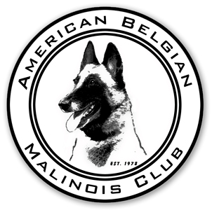
American Belgian Malinois Club, an AKC Member Club

Membership Renewal Form & Notice for 2017
Return to: Jane Rothert, 2705 Clifton Drive, Urbana, IL 61802-7621

Please return this form with your dues. $5 late fees apply on renewals that are postmarked after December 31, 2016 and before March 1, 2017. AFTER March 1, 2017 unpaid memberships are considered lapsed, and require a new application and sponsor. This policy will be STRICTLY enforced.

Donations to the Rescue Fund are made as a separate check payable to the ABMR Charitable Trust. Contributions to the trust are tax deductible and a receipt will be sent to you for your records. Checks made out to ABMC for membership renewal that include monies for the Charitable Trust will be returned.

Donations to the health and national funds will be gratefully accepted. The IRS has asked us to state that membership dues and donations to the health & national funds are not tax deductible.

Membership renewal fees and donations to ABMC (not the Charitable Trust) may be paid online using PayPal (there is a 3% surcharge added to cover the PayPal fee). If not using PayPal, the following form must be signed and returned via snail mail or email.

Any questions? Please contact Sara Andersen, 308 Scott Road, Rocky Point, NC 28457 email: sarajane3@twc.com Phone: 717.487.3323

ABMC 2017 Membership Renewal
Names:
Address:
City, State:
Email:
Website:
Home phone: |  | List on roster: Y N
Work phone: |  | List on roster: Y N
Cell phone: |  | List on roster: Y N

Dues Enclosed: $40 Individual $________
$65 Family (2 adults, same address) $________
$10 Junior (age 10-17) $________
Late Fee ($5 if postmarked between January 1, 2017 and March 1, 2017) $________
Performer 1st Class and Foreign Postage $15 (Normal Bulk no charge) $________
Donations: Health Fund $________ National Specialty $________
Total payable to ABMC $________

I authorize the ABMC to send official communication to me by electronic (email) means only. AKC requires the Club have a signed authorization from each member allowing the exclusive use of electronic methods for official ABMC communication. Each member in a family membership (adults over 18 only) must sign if the family wishes to receive club information by email.
 Yes Signature: _______________________________________________________________
 No, I wish to only get information through the postal system.

