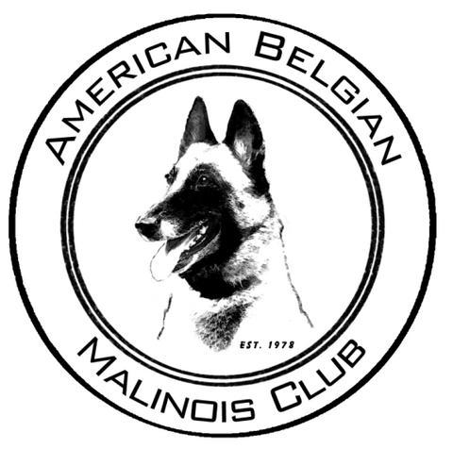

MEET THE BREED

Approved/Suggested documents to use at Meet the Breed events:

These are found on the clubs web site www.malinoisclub.com

Breed Standard
History of the Breed
Breed Standard video
ABMC list of breeders
AKC Marketplace list of breeders URL
ABMC Code of Ethics
ABMC How to identify a reputable Breeder
List of upcoming dog shows in the specific area of the MTB event.

An article written by Carilee Moran:
https://www.akc.org/expert-advice/dog-breeds/getting-right-belgian-malinois-good-fit/

