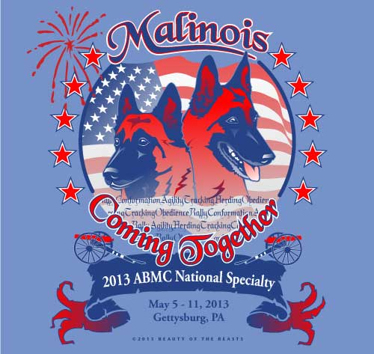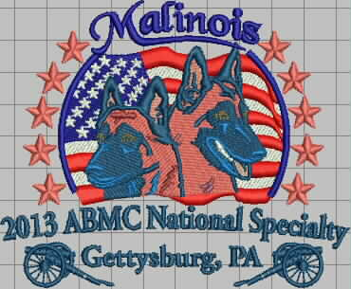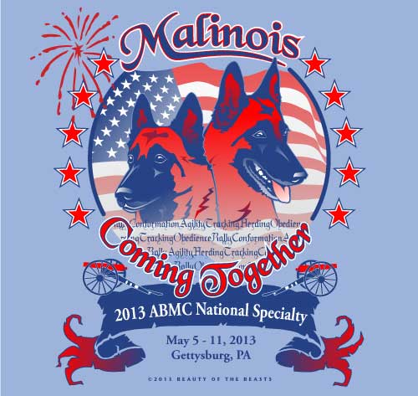
Print on Iris Shirt Embroidered Print on Carolina Blue

2013 National Specialty Merchandise
This year we have many different items for you to choose from!
Beauty of the Beasts has once again provided us with a beautiful logo!
With their permission, Besco Awards has worked with the logo so that it can be embroidered.

All items must be pre-paid, and can either be shipped to you, or you can pick them up at the National. Shipped orders will not be mailed out until May 13, 2013 A limited supply of featured merchandise will be available for sale at the specialty.

Please fill out the following form and send your order to:
Sally Atterberry
POB 27
Oakford, IL 62673
salwex@aol.com

All orders must be pre-paid and received by March 27, 2013.

Payment Options:
Check: Make check payable to ABMC
Credit Card: Include credit card info on order form.
PLEASE DO NOT SEND CASH

Prices and Sizes:
Printed Items
All short-sleeved tees: XS-XL: $20, 2X: $21, 3X-5X: $22
Baseball style tee (short sleeve): XS-XL: $23, 2X $25
Baseball style tee (3/4 sleeve): XS-XL: $23, 2X $25
All long-sleeved tees: XS-XL: $23, 2X: $24, 3X-5X: $25
Crewneck sweatshirts: S-XL: $29, 2X: $30, 3X-5X: $31
Pullover Hoodies: S-XL: $34, 2X: $35, 3X-5X: $36

Embroidered Items:
Women’s Silk Touch Polo Shirt: XS-XL: $30, 2X-5X: $32
Men’s Silk Touch Polo Shirt: XS-XL: $30, 2X-5X: $32
Ladies Yoga Shirt: XS-XL: $40, 2X-4X: $42
Ladies Yoga Hoodie: XS-XL: $45, 2X-4X: $47
Zip Front Hoodie: S-XL: $40, 2X-3X: $42
Ladies Fleece Vest: XS-XL: $35, 2X-4X: $37
Polar Fleece Vest: XS-XL: $40, 2X-6X: $42
Heavy Fleece ¼ Zip Jacket: XS-XL: $42, 2X-6X: $44
Polar Fleece 3 Season Jacket: XS-XL: $65, 2X-6X: $67
Ball Cap: One Size Fits Most: $20
Fleece Throw Blanket: 50x60: $25

Thermal Traveler Mug
16 oz full color specialty logo (no handle): $15

Windshield Sun Shade
Silver with club logo: $15

Catalog
Obedience/Rally/Sweepstakes/Juniors/Conformation Only
$5
Catalogs for Tracking, Herding, and Agility will be available at those events.
Marked catalogs not available.

Shipping within the US is $6.00 for 1-2 shirts, $7.00 for crewneck sweatshirt, and $8.00 for hoodie. The shipping for 3 or more items is $11.00. A $2.00 handling fee will be added per order.

Printed Items
Available Colors and Sizes:

Men’s Tee (short and long sleeve):
XS-5X: Carolina Blue, Light Blue, Light Pink, Heather Grey, White
Women’s Short-Sleeved Tee:
XS-2X: Heather Grey, Light Blue, Light Pink, White
Women’s Long-Sleeved Tee:
XS-2X: Violet, Rose, White
Unisex Crewneck Sweatshirt (runs very large, order one size smaller):
XS-5X: Carolina Blue, Light Blue, Light Pink, Heather Grey, White
Unisex Hoodie (runs very large, order one size smaller):
XS-5X: Carolina Blue, Light Blue, Light Pink, Heather Grey, White

Italian Charms with National Specialty Logo:
Mega charm: $20
9mm square charm: still in the works. Please email me if you are interested so I can
put you on a list.

Embroidered Items
See flyer for photos of these items
Available Colors and Sizes:

Polar Fleece 3 season jacket: XS-6X: slate blue, red
Ladies Fleece Vest: XS-4X: light royal, hot pink
Women’s Silk Touch Polo Shirt: XS-5X: lime, cool grey, banana
Men’s Silk Touch Polo Shirt: XS-5X: royal, red, steel grey
Ladies Yoga Shirt: XS-4X: iris, dusty rose
Ladies Yoga Hoodie: XS-4X: chive green, amethyst
Zip Front Hoodie: S-3X: grey, red, navy
Heavy Fleece ¼ Zip jacket: XS-6X: royal, red
Polar Fleece Vest: XS-6X: grey, royal
Baseball Cap: light blue, red, navy
Fleece Throw Blanket: navy, grey, red

Catalog:

Pre ordered catalogs can be picked up at the ABMC booth on May10th or May 11th.

Shipping Information:

Name: ________________________________
Street Address: ___________________________________________
City, State, Zip Code: _______________________________________
Phone Number: _____________________________________
Email Address: ______________________________________
Credit Card Info:
Name on Card: _______________________________________
Card #: ____________________________________
Exp Date: __________________
Code on back of card: ________

Item | Quantity | Size | Color | Price
 |  |  | Sub Total
 |  |  | Shipping (If Applicable)
 |  |  | Handling (If Applicable)
 |  |  | Total

